MrBCRC EBC

Additional information can be found at www.mrbcrc.com

Foreword
It is acknowledged that this manual will somewhat always be incomplete. It’s the nature of the game for largely hand build products that are in continual development.
Please refer to the online videos on the MrBCRC YouTube channel for tutorials on the devices.
Due to the continual development of the device there will always be variations between the devices some minor and some more significant.
If there’s anything you need an explanation of just contact support@mrbcrc.com
Regardless of that lets get down to business…
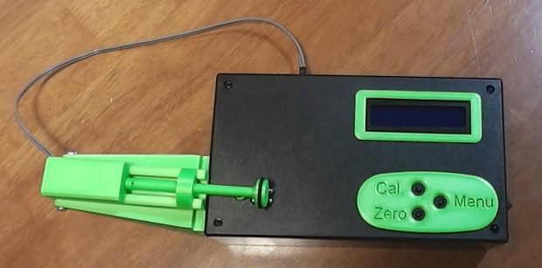

What does it do?
The EBC uses electromagnetism to detect the presence of copper which is obviously the jacket material of our projectiles. Subsequently it also measures brass, steel and aluminum but not lead.
Electromagnetically speaking each of those metals behaves vastly different to each other and these units are tuned precisely to handle copper only.
These units are obviously going to be compared to the Original Juenke units and honestly it was the desire for a Juenke that led to the independent development of the EBC. The science behind them is identical however the circuit and sensor design differs significantly but no matter the differences the principles are the same.

Getting started (what is what?)
Compare your unit with the images below.
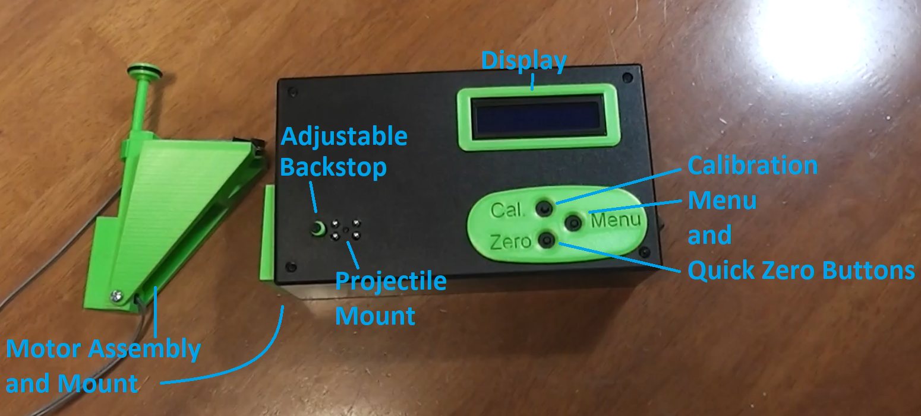

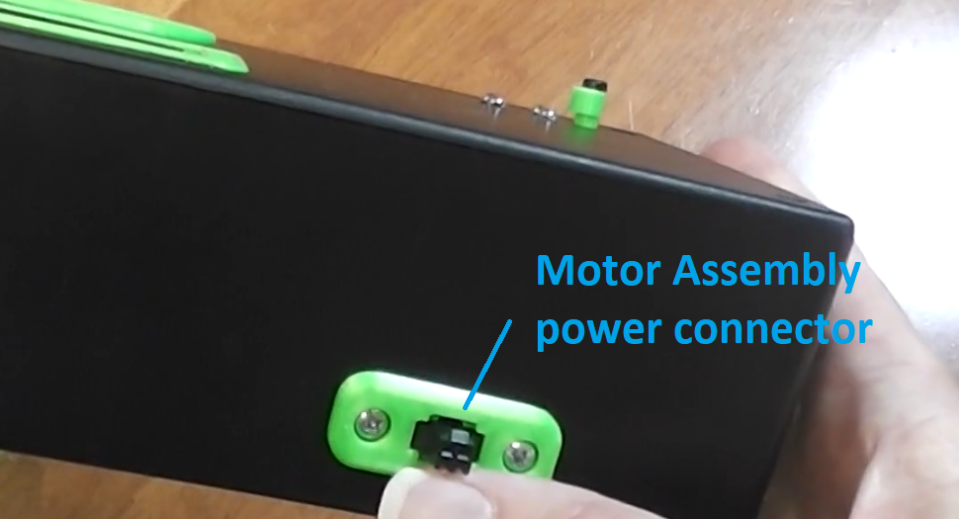

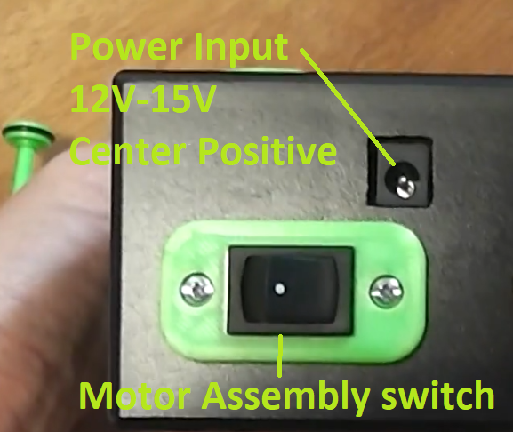

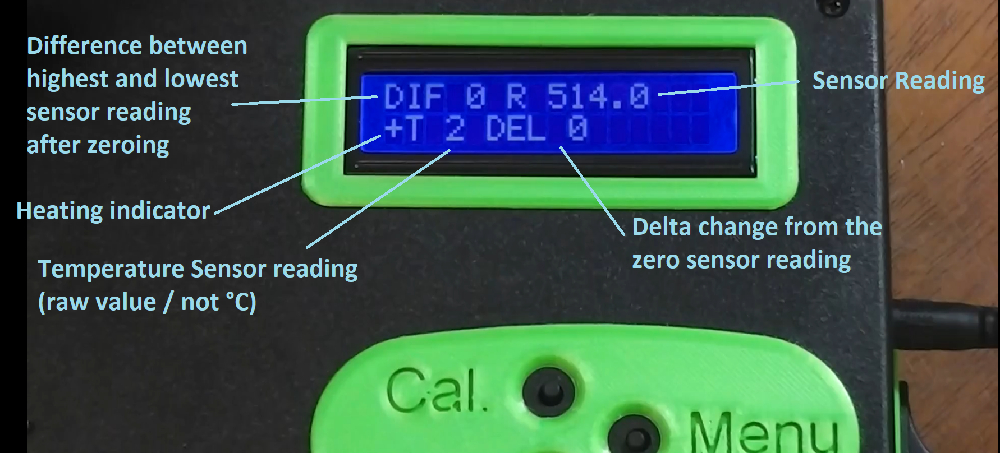

Menu Items
Press the menu button to enter the menu. Press the menu button again to move to the next menu item.
The first menu item allows for coarse adjustment of the calibration zeroing value. This value will generally be set during calibration in order to compensate for temperature variations of the unit and also the projectile in use.
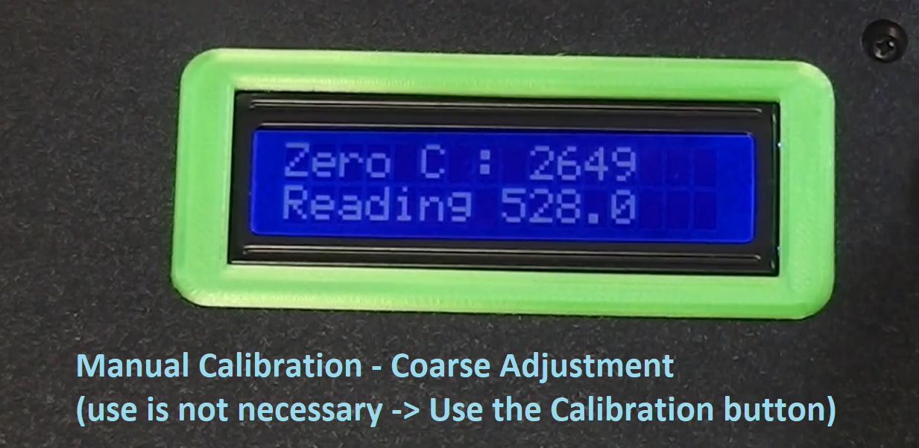
The second menu item allows for fine adjustment of the calibration zeroing value. As with the coarse adjustment, this value will generally be set during calibration in order to compensate for temperature variations of the unit and also the projectile in use.
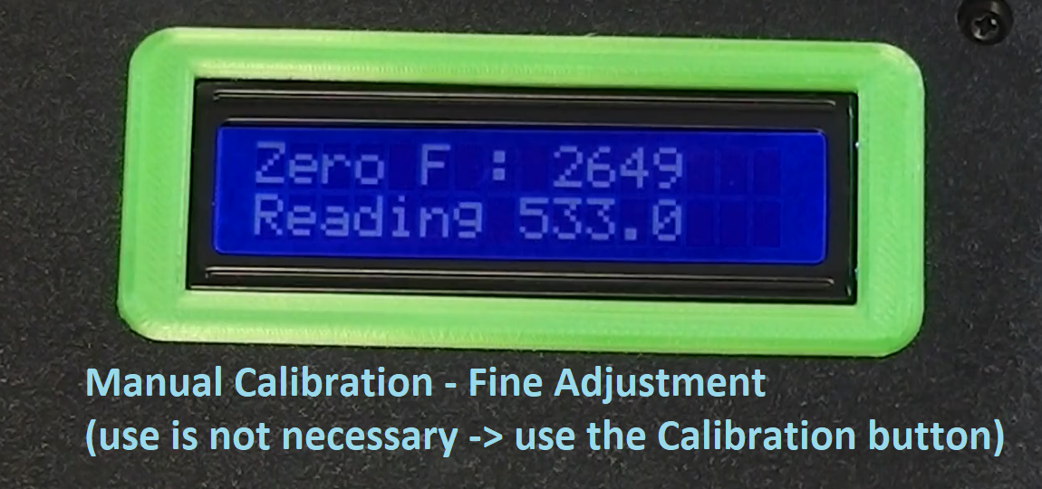

The next menu item allows you to switch the internal heating element (if one is installed) on or off.
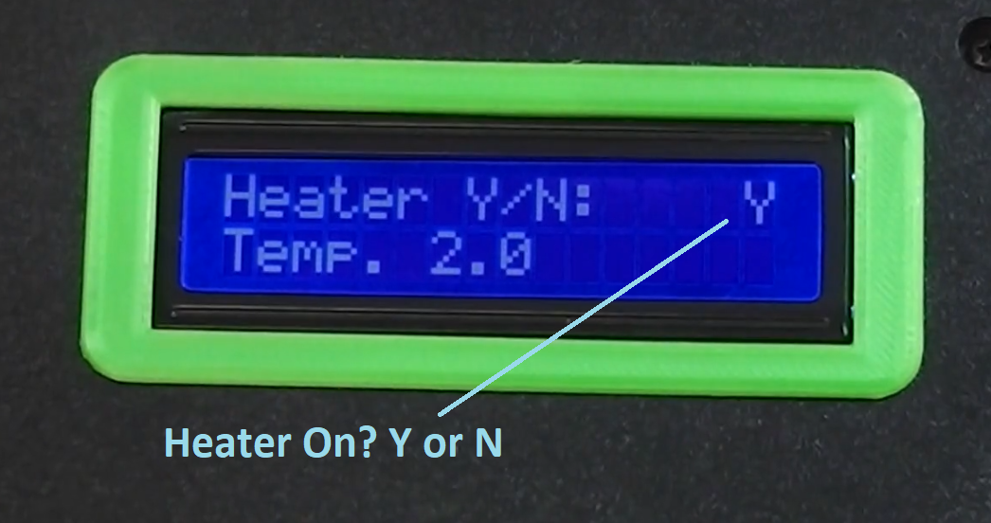
The next menu item allows for setting the target temperature for the heater. Note that temperature in these units is NOT in degrees of any scale. The temperature sensitivity is so high that these units are generally configured such that one temperature unit is approximately 0.025°C.
Ideally set a temperature that is slightly higher than the ambient temperature that will be displayed at startup. e.g. 60 is a good value when the ambient is below the minimum as per the image shown
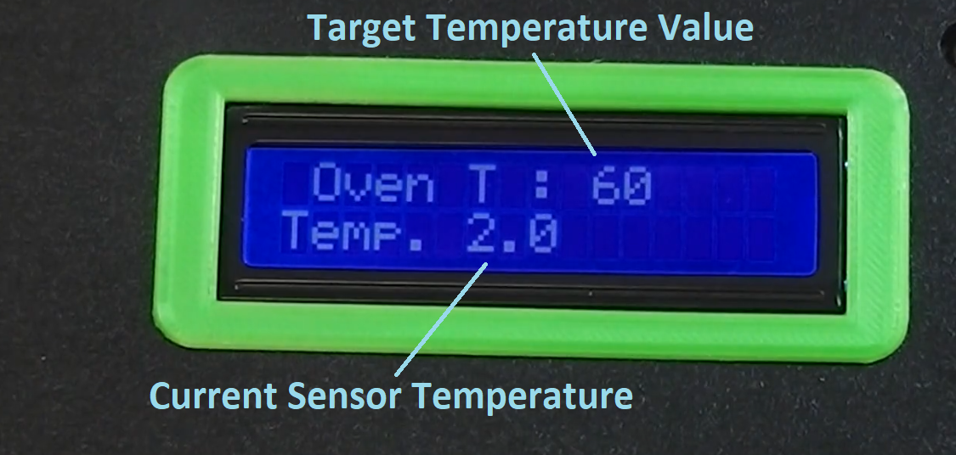

The next menu item allows for access to additional menu settings. Primarily that means rearranging what is displayed on the main screen during measurement but be warned changing the display will make it not match any documentation and will cause confusion when you go to use it in 6 months time and nothing matches up.
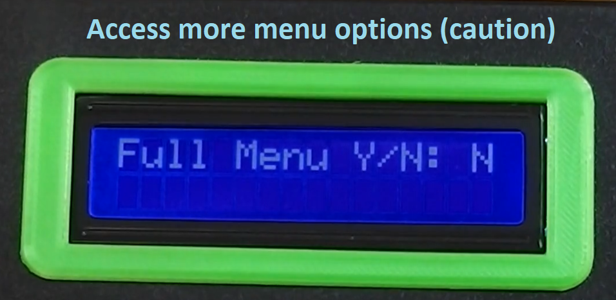
The last menu item allows you to write your changes to the chip to be loaded on restart.
Generally this is unnecessary for normal operation and the unit will be configured for operation when sent out. Where it will likely be used is to save the temperature setting when the typical ambient temperature is significantly higher or lower than the unit is set for and you find you are adjusting the Temperature a lot
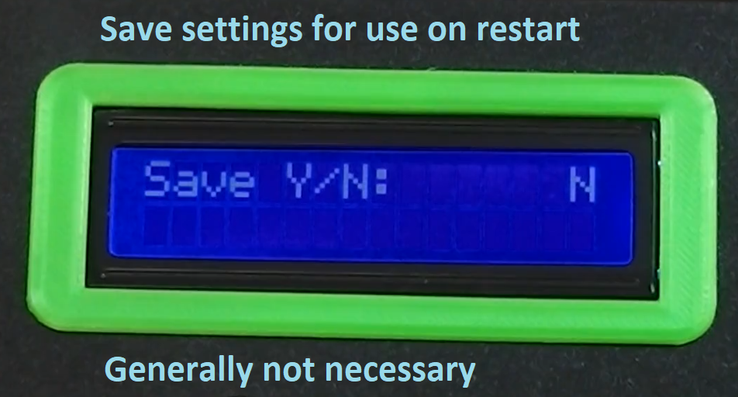

Operation
Place the projectile on the ball bearings as shown. Adjust the backstop to ensure that the projectile is seated securely. The motor drive can be used to pull the projectile back onto the backstop as it rotates the projectile.
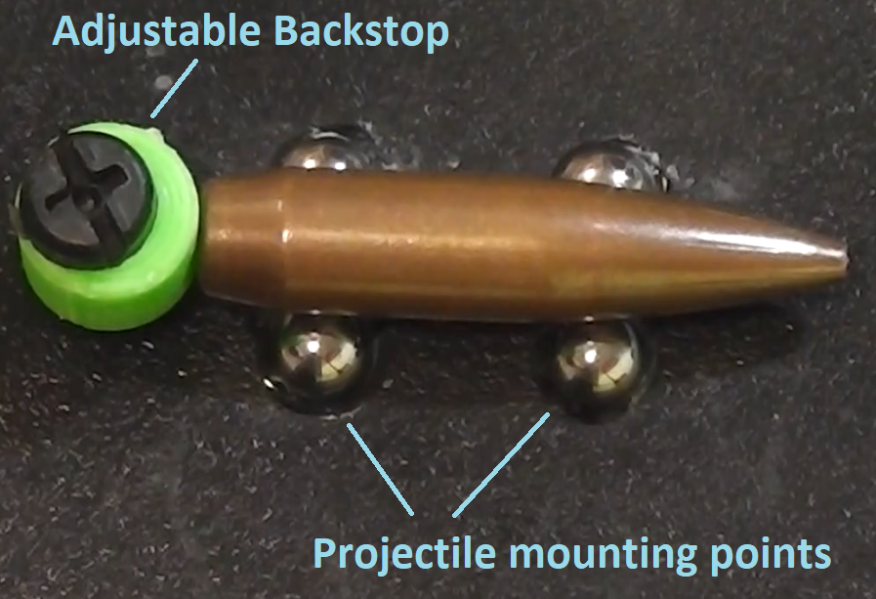
With the projectile in position and the motor drive arm down and the Motor Turned OFF press the Calibration (Cal.) button. This will configure the unit for the specific projectile at the current temperature.
When calibration is complete you can turn the motor on and commence measurement of the projectile.
NOTE: Keep an eye on the Reading (R) because it will drift as the unit warms up and if it drifts more than 100 from the 512 mid-point of the sensor then another calibration will be required. Calibration can be pressed at any time in order to counter temperature drift and if the device determines that a full calibration is not necessary then it will simply perform a re-zero.

Measuring
Place the projectile down on the bearings.
Lower the motor drive arm down onto the projectile.
Wait for it to pull the projectile back onto the backstop.
Press the zero button…
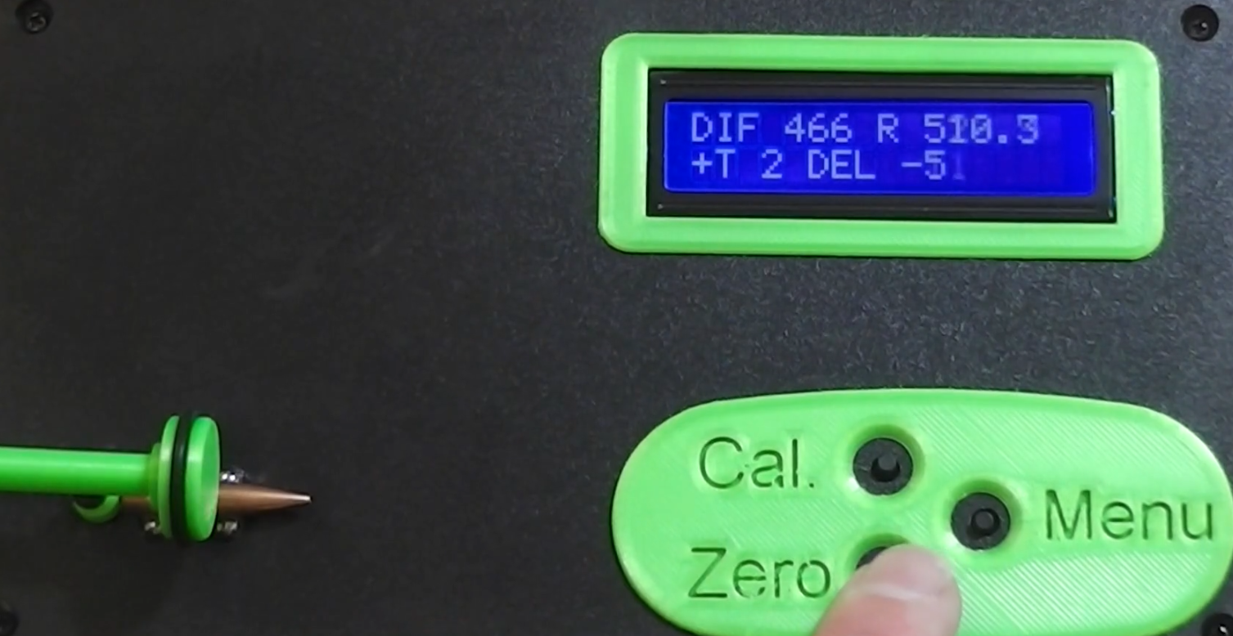
Zeroed…
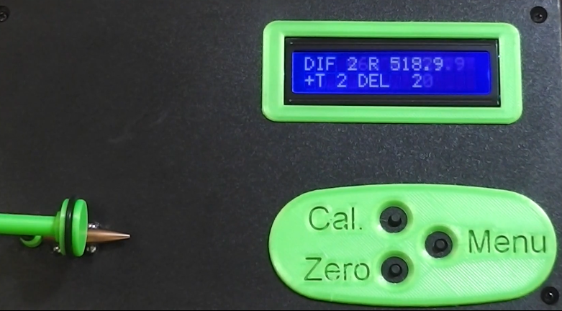
Measuring…
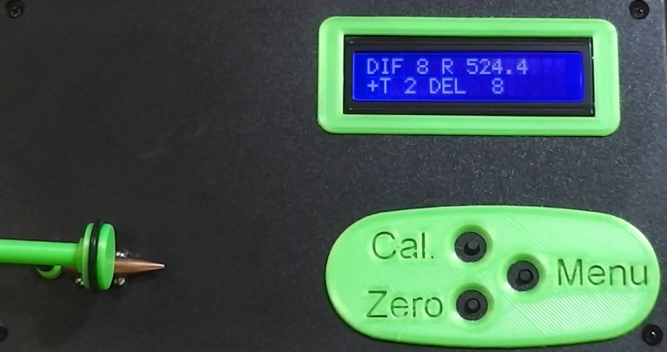
Measurement complete
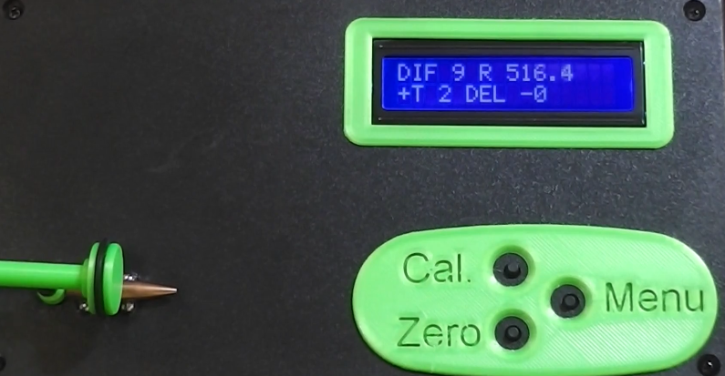
Repeat as needed to be confident of the measurement.

Measurement, Batching and Things to be aware of…
Be aware that what we’re measuring is so tiny that temperature plays a huge part in what is measured. Even the projectile heating up from handling can cause the copper to expand and alter its displayed measurement slightly.
There is a lot of filtering in the measurement process to remove wild outliers due to temperature and electrical signal noise. When starting off using the device it is recommended that you become familiar with the fact that the measuring the same projectile 3 or 4 times in sequence will likely produce a small variation in readings.
Analogue meters like the original Juenke naturally filter out those wild outliers and they become jitter in the needle. Digital devices like the EBC are not so forgiving and some of that temperature and signal noise will creep into the measurements.
e.g.:
8, 9, 9, 10 you could call a 9 for batching purposes.
Or
16, 18, 20, 19 for you could call a 19 for batching purposes.

The measurements you receive are relative measurements. It’s best to think of the EBC as a set of precision divider calipers and not vernier calipers. You get relative measurements and not absolute measurements. This makes comparing measurements with those from other devices unrealistic (but not impossible).
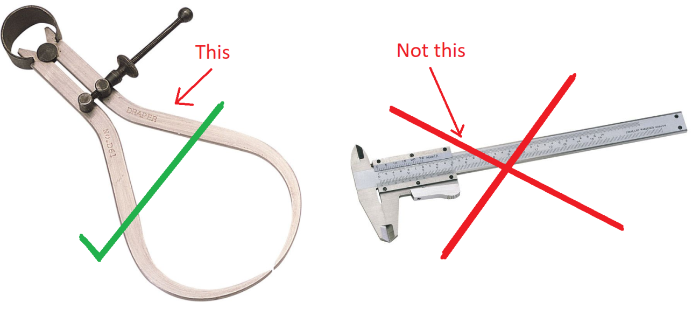
Caution is necessary e.g. if you are told a measurement of 9 is great for your projectile on someone else’s device you might find that on your device that projectile may actually be a 5 which means a 9 would actually be a bad one, or that projectile may read as a 13 and you could be excluding good projectiles that read between 9 and 13 on your device.
Subsequently a reading of “x” does not equate to a diameter of “y” or a jacket thickness of “z”

Choosing batch ranges.
Unfortunately batching ranges and by implication their sizes are not absolute due to the personal requirements of the shooter, the consistency of the projectiles and the tuning variations between the different machines.
Work out how many batches you need… e.g. Sighters, Club Comp and Prize Meeting would give you 3 batches.
I would then suggest including 2 additional batches sitting between the three that you need and a final batch for the one or two complete trash projectiles that you wouldn’t even use for sighters that sometimes appear in a packet of projectiles.
Next take 10 to 15 random projectiles and measure them on the EBC to work out what your batch ranges are likely to be.
After measuring all of your projectiles if you require 50 projectiles for a prize shoot and you only have 45 in your best batch you can borrow 5 from the intermediate batch knowing that they are better than what is in your club shoot batch.
With experience you will come to understand what batch ranges are relevant for your projectiles and your shooting requirements.
Batch Ranges will vary by calibre. Larger projectiles sit further from the sensor and will read as having smaller variations for the same physical deviations in the projectile. Ensure that you adjust your batch ranges for each and every projectile type your measuring for and don’t just use .22 cal ranges for your 7mm or .30 cal.

